1. **Right-skewed Distribution:**

When the distribution has a long tail towards the right side, then it is known as a right-skewed or positive-skewed distribution. In the right-skewed distribution, the concentration of data points towards the right tail is more than the left tail.

**In the right-skewed distribution: Mean > Median> Mode.**

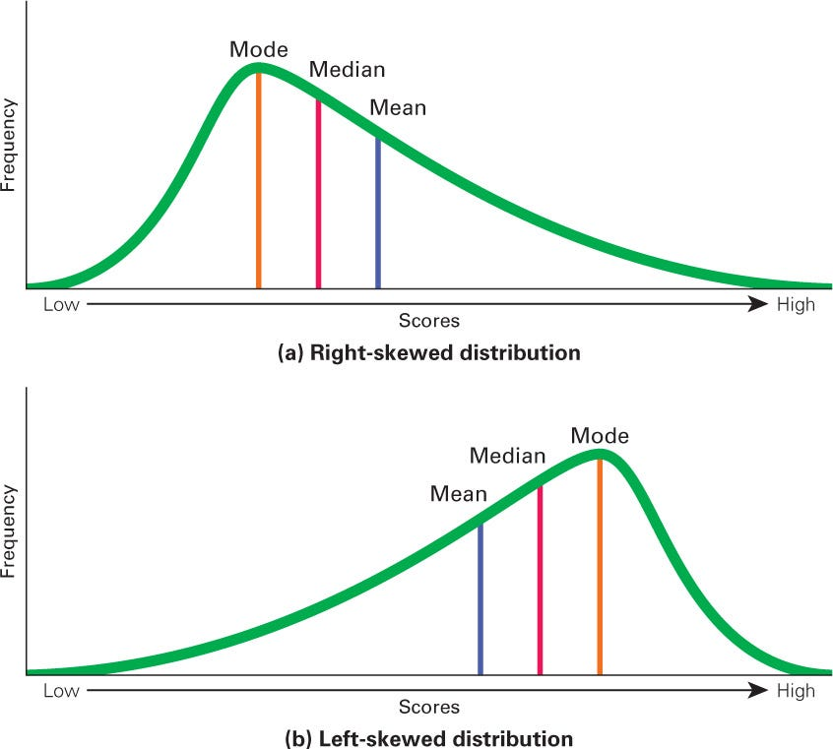

<https://www.macmillanhighered.com/BrainHoney/Resource/22292/digital_first_content/trunk/test/griggs4e/asset/ch01/c01_fig05.jpg>

2.**Left-skewed Distribution:**

When the distribution has a long tail towards the left side, then it is known as a left-skewed or negative-skewed distribution. In the negative-skewed distribution, the concentration of data points towards the left tail is more than the right tail.

**In the left-skewed distribution: Mode > Median > Mean**

3.**Zero-skewed Distribution:**

When the distribution’s left side is symmetrical to the right side then it is known as a zero-skewed or normal distribution. In the zero-skewed distribution, the concentration of data points toward the left tails is the same as toward the right tail.

**In the zero-skewed distribution: Mode = Median = Mean**

